**Capstone Project - The Battle of Neighbourhoods: Should I move from Lausanne to Bern?**

**Christopher Tse, Dec 2019**

## **1. Introduction**

I'm currently living in a city called Lausanne, on the French-speaking side of Switzerland, but there may be more job and life opportunities in a German-speaking city called Bern in Switzerland. I want to use data science to help me decide which city would suit me best to live.

I want to compare the livability of the two cities through using similar methods that have been used in the assignments from this course, and help me decide which area would be best for me - a young adult.

## **1.1 Problem**

I have not been to Bern very often and don’t know the area well. I don’t know of a method to survey areas of a city to quickly assess the types of venues that are nearby. It would be immensely valuable for me to be able to see on a map, the kind of neighbourhood a location is to quickly give me an impression If it’s a liveable place for me.

## **1.2 Interest**

This can be used by anyone, who wants to assess the local area to help them decide if it’s a suitable place for them to live, or open new business opportunities by identifying missing wanted venues.

## **2. Methodology - Data acquisition and cleaning**

Using Foursquare, I first start at the train station from each city. From the train station, I select all Migros supermarkets in the region. From each Migros supermarket, I list out all nearby venues within 1 km, compile into a list and use kcluster to match similar neighbourhoods together. These will be displayed onto an interactive map with folium and help me decide which areas I would like to live. This will be done with k-means to segment and cluster related neighbourhoods to allow me to estimate the suitable demographic to live there. I will be interested in areas which are near a supermarket for convenience, and survey the types of venues in the area. The use of folium interactive maps would be very useful here also so I can visually see attractive features like rivers and parks in the respective areas to strengthen the validity of my recommendations.

There is a limit to how many venues each query can retrieve (up to 50), therefore I will need to break up my query into several queries to cover as much of each city as possible. A local governmnet-run supermarket chain called Migros are well distributed across all cities to provide the sale of groceries to the local populations. I will use these as local "neighbourhoods" to capture as many venues as possible.

## **2.1 Data sources**

In this project, I used Foursquare’s venue data to compare the most interesting regions of Lausanne and Bern.

## **2.2 Data cleaning**

When retrieving the data from Foursqure, the data is collected in a JSON file, which needs to be converted into a pandas dataframe for further manipulation to only have the necessary data still present. Such unnecessary labels include “hasPerk”, “location.cc”, “location.country” etc.

What was kept was parameters which were useful such as id, lat and lng (identity, latitude, longitude respectively).

Such data types allowed me to create interactive maps to show the areas of interest.

## **Results and Discussion**

Using the train station as a starting point, all Migros supermarkets are identified with the Foursquare API in the city (Fig. 1). They can be seen to be dotted around the cities, with an aggregated cluster in their respective town centres.

- Lausanne -

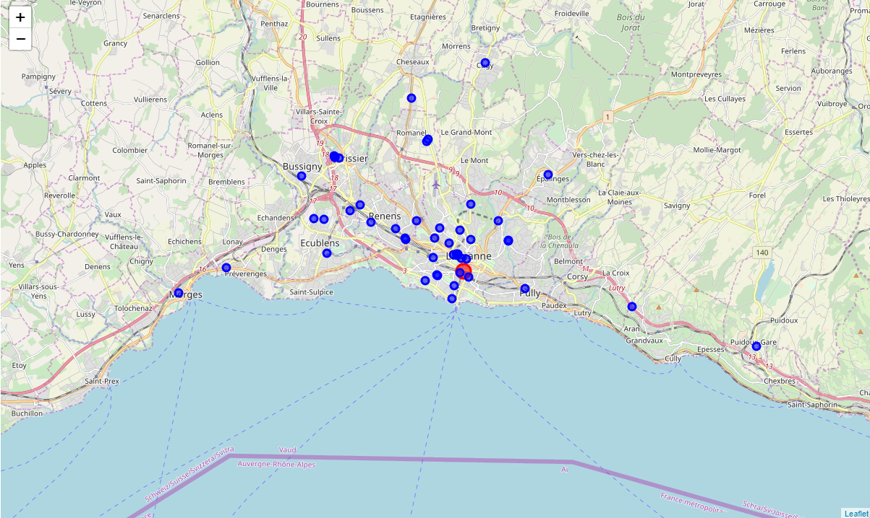- Bern -

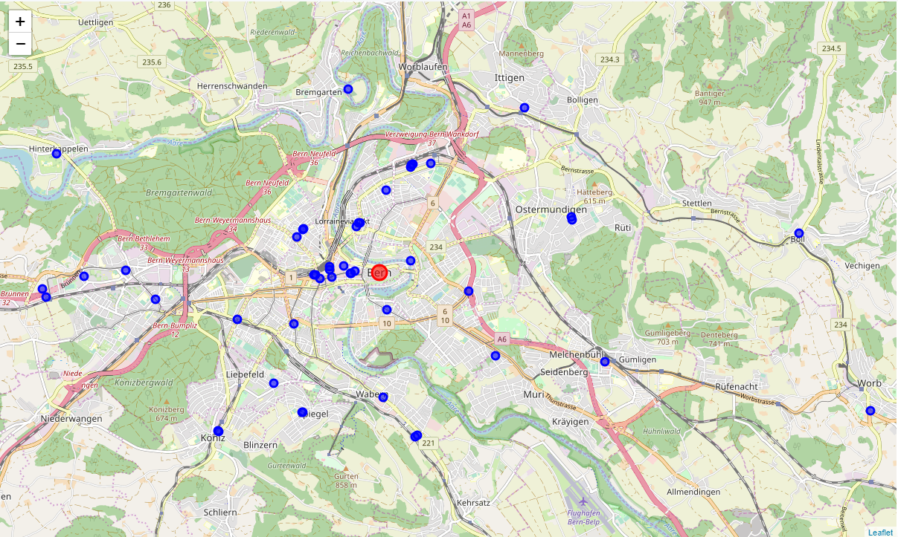

Fig. 1 showing screenshot of folium map of Migros in each city (blue), centred around the train station (red).

Using the supermarket at a reference point provides good coverage of each city. Having identified the supermarkets, their latitude and longitude positions are recorded and the “getNearbyVenues” function was used to list all local venues around each Migros supermarket. The closest venues are

When writing the script, I used each venue’s unique id (“id”) as their name so each entry was unique because many of the supermarkets are simply called “Migros” and manipulation of the data would have aggregated results in later pieces of code.

A total of 1612 venues were collected from 131 unique categories, ranging from Art galleries to Zoos (Fig. 2)

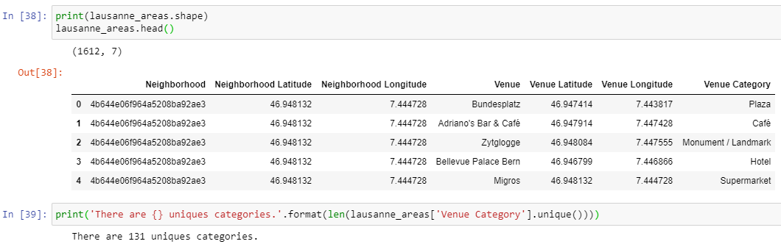Fig. 2 showing a caption of the code that collected the total venues and categories all around Lausanne

To view each area more efficiently, the data was aggregated into a pandas dataframe with the top 10 venues shown (Fig. 3). By viewing the most common venues, I can get a grasp of the kind of environment each area has.

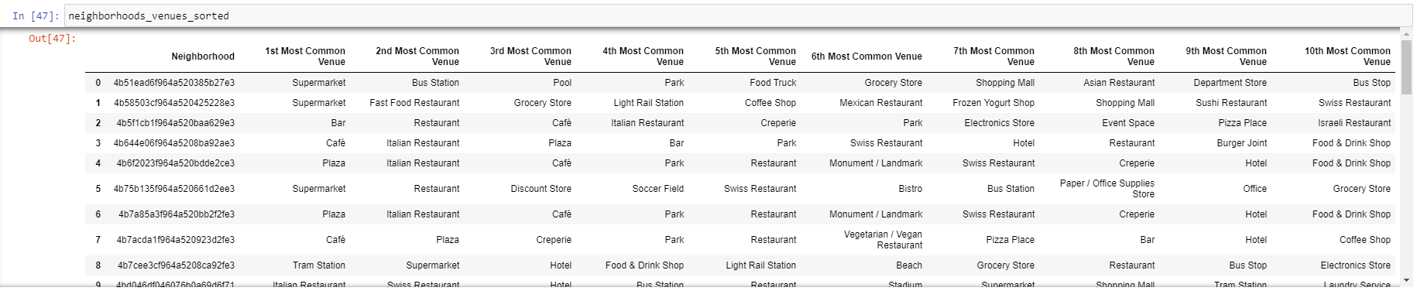Fig. 3 showing a caption of the code that ranked the top 10 venues at each area in Lausanne

With 49 different areas to assess, and each having the 10 most common venues, I would need to inspect 490 fields of data for each city, which is too much for convenience. A better way to arrange and sort the venues was required and needed further data manipulation. Instead of reviewing each of the 49 areas, I used kcluster with a k-value of 8 to cluster similar areas together, reducing the analysis from 490 fields of data to 80 (Table 1). Any value of k could have been chosen. I had initially chosen 5, but I wanted a bit more complexity to my resulting data.

- Lausanne -



















- Bern -



















Table 1. Comparative study of the top 10 venues in each city of Lausanne and Bern, by each cluster generated by kcluster with a k-value of 8

Table 1 gives an excellent summary of each cluster that can help me narrow down my ideal area to live. However, it is still quite text heavy and some of the venues are of no interest to me. It would help to further refine the data so it’s easier to discriminate against unwanted venues in each area. With the top venues now visible for each area, I can simplify each unique category to better decide which area is more attractive. I want to live near public transportation, food establishments, close to shopping venues and have leisure activities close by. All other things which are of interest to me can be considered unwanted i.e. dance studio, gas station, health and beauty service etc (Table 2). I created Table 2 through assessing each of the unique venues by hand. This could have been automated if I had assigned a label for each unique venue and automatically create a new table for me. This was considered too labour intensive at this time as I only wanted to generate two tables. If I use this same script presented in this project for several thousand different cities and areas of interest, it would be worthwhile to create this sort of table automatically through using pandas and dataframe manipulation.



Table 2. Sorting all venues into relevant labels to better assess the attractiveness of each cluster.

With the data provided by Table 2, it is easier to pick the clusters which would be of least interest for me i.e. clusters with “unwanted” venues. Ideally there should be a lot of leisure venues, little consumer shopping venues and at least one public transport venue nearby. By setting these criteria, I get Table 3, which shows that cluster 1 in Lausanne, and cluster 3 and 7 in Bern would be ideal as they fulfil my criteria.



To better visualise the clusters, Folium was used again and this time each Migros supermaket was colour-coded to the cluster they are associated with (Fig. 4). Cluster 1 in Lausanne is coloured purple, and cluster 3 and 7 in Bern are coloured faded blue and orange respectively.

- Lausanne -

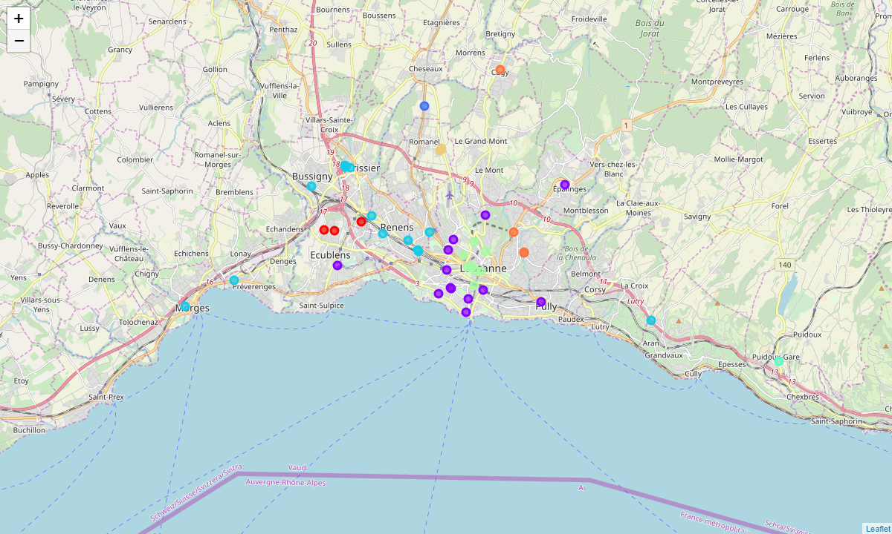- Bern -

## Fig. 4 showing screenshot of folium map of Migros in each city, colour-coded to each clister; Red = 0, Purple = 1, Navy Blue = 2, Faded Blue = 3, Turquoise = 4, Lime Green = 5, Mustard Yellow = 6, Orange = 7

## **Conclussion**

The folium interactive map is very useful to represent the data and is very easy to survey the local area.

With Lausanne, through the use of data science, it was concluded that areas around cluster 1 (purple circles in the map of Fig. 4) are ideal. Seeing the locations, they are situated mostly in the city centre and there are three areas outside of the city centre; at Ecublens, Pully and Epalinges. Ecublens, with its close proximity to public transport and nice location, would be of most interest to me to live.

With Bern two areas identified with kcluster were ideal for me; 3 and 7 (faded blue and orange in Fig. 4). With this information, combined with the folium map, I conclude that cluster 7 (orange) would not be suitable as it looks too far away from the city and is too rural for me, therefore cluster 3 (faded blue) would be of most interest, specifically the orange area nearest to the centre of Bern.

I can conclude that if I were to move to Bern, I would want to move near the North of the city centre where there are the most attractive venues for me. If I should stay in Lausanne, then living somewhere near Ecublens would be ideal.

This script created for this project allows:

1. Contextual summary through combining Foursquare API and folium to assess attractiveness of each area.

2. Can be used for any city and any point of interest in the world making this translational for not just my needs, but for businesses and organisations to create contextual data of areas of interest.

3. Have up-to-date data as long as people still use the Foursquare API

4. Tailor the methodology easily i.e. radius, number of kclusters, vary the number of most common venues, change city and change areas to search can all be simply amended in the code.

However I did stumble upon some drawbacks which had caused inaccuracies and errors in the data;

1. Venues can have multiple unique venue ids, and human errors due to decentralised method of data collection by the general public. This is the strongest argument against using this technique. Less popular cities may not have up-to-date data. This is popular in the US, but less popular in Europe which can affect their accuracy. All further disadvantages to this method stems from this weakness.